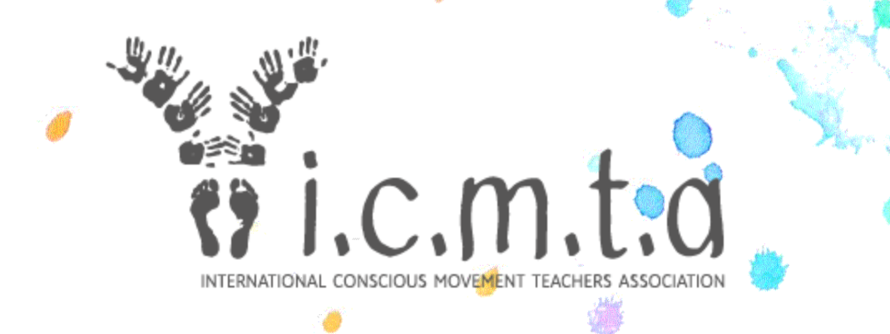

ICMTA Mediation Resources

Book / Reading Resources

1. The Zen of You and Me: A Guide to Getting Along with Just About Anyone, Diane Musho Hamilton
How to deal with interpersonal conflict--from a Zen perspective.
The people who get under your skin the most can in fact be your greatest teachers. It’s not a matter of overlooking differences but of regarding those difficult aspects of the relationship with curiosity and compassion--for those very differences offer a path to profound connection. Diane Hamilton’s practical, reality-based guide to living harmoniously with even your most irritating fellow humans—spouses, partners, colleagues, parents, children--shows that “getting along” is really a matter of discovering that our differences are nothing other than an expression of our even deeper shared unity.

2. The Mediation Process: Practical Strategies for Resolving Conflict, Christopher W. Moore
Expensive but the most comprehensive book written on mediation, this text is perfect for new and experienced conflict managers working in any area of dispute resolution family, community, employment, business, environmental, public policy - multicultural, or international.

3. Nonviolent Communication, Marshall B. Rosenberg , Foreword by Deepak Chopra

What is Violent Communication? If "violent" means acting in ways that result in hurt or harm, then much of how we communicate--judging others, bullying, having racial bias, blaming, finger pointing, discriminating, speaking without listening, criticizing others or ourselves, name-calling, reacting when angry, using political rhetoric, being defensive or judging who's "good/bad" or what's "right/wrong" with people--could indeed be called "violent communication."

Nonviolent Communication is the integration of four things:

- Consciousness: a set of principles that support living a life of compassion, collaboration, courage, and authenticity
- Language: understanding how words contribute to connection or distance
- Communication: knowing how to ask for what we want, how to hear others even in disagreement, and how to move toward solutions that work for all
- Means of influence: sharing "power with others" rather than using "power over others"

Nonviolent Communication serves our desire to do three things:
- Increase our ability to live with choice, meaning, and connection
- Connect empathically with self and others to have more satisfying relationships
- Sharing of resources so everyone is able to benefit

4. Changing the Conversation: The 17 Principles of Conflict Resolution, Dana Casparen
You can't change how other people act in a conflict, and often you can't change your situation. But you can change what you do.
Changing the Conversation is a graphic, two-colour manual that teaches essential strategies for resolving conflict in your life. Breaking the process down into 17 easy-to-grasp principles, it shows how you can facilitate listening and speaking, build useful dialogue and look for ways forward.
5. Sex and the Spiritual Teacher: Why it Happens and When It’s a Problem, Scott Edelstein
Looks at the complex of forces that can tempt otherwise insightful, compassionate, and well-intentioned teachers to lose their way--and that tempt some of their students to lose their way as well. It analyses why most of our current efforts to keep spiritual teachers from transgressing sometimes don't work. It includes a set of practices and structures that can build community, encourage healthy student-teacher relationships, increase trust and spiritual intimacy between teachers and their students.

YouTube Resources

1. Mediation Resources, with Diane Musho Hamilton

1.1 Having Challenging Conversations

https://www.youtube.com/watch?v=o8gVO6p6vdM

1.2 Everything is Workable: A Zen Approach to Conflict Resolution
https://www.youtube.com/watch?v=UDekZGJ5Y-c
Learn how to deal with conflicts more skilfully from state supreme court mediator and Zen master Diane Hamilton. Ignoring conflicts usually won't make them go away, but if you approach them consciously, you can navigate conflicts in ways that not only honours everyone involved but also makes them a source of deep insight as well. Diane will show you how to engage conflict with wisdom and compassion by:

  - Cultivating the mirror-like quality of attention as your base
  - Identifying three personal conflict styles and determine which ones you fall into
  - Recognizing the three fundamental perspectives in any conflict situation
  - Turning conflicts in families, at work, and in every kind of interpersonal situation into win-win situations

Reduce stress in your life by learning these techniques and transform the way you handle conflicts in your life.

1.3 The world of mediation

https://www.youtube.com/watch?v=booaYWZbd-c
Meditation teacher and mediator Diane Hamilton joins me to discuss the Zen of conflict.

2. Mediation and mindfully getting in the middle: Brad Heckman at TEDx Teachers College

https://www.youtube.com/watch?v=UUVmPVKaJzk

In this insightful talk, Brad Heckman discusses mindfulness in conflict mediation. Using poignant humour and his own hand-drawn illustrations, Heckman effectively communicates the necessary balance of emotions, relief and reflection that mindfulness supports in the mediation process.

Brad Heckman is the founder and CEO of the New York Peace Institute and is committed to helping people resolve conflicts by finding creative, durable, and peaceful solutions.

3. Essentials - An online mini-course with teachings and meditations with Thomas Hübl & William Ury

https://ondemand.thomashuebl.com/p/meditate-and-mediate-essentials/

Learn from two masters how to blend the inner art of MEDITATION with the outer art of MEDIATION - Drawn from the rich library of Meditate & Mediate teachings, this mini-course contains seven short video modules plus three powerful meditation experiences. The tools and exercises they reveal will give you new access to creative solutions.
If you could use fresh insight on a difficult situation, the material in this mini-course can forever change the way you view conflict.
4. Conflict is a place of possibility, Dana Caspersen, TEDx Hackney Women

https://www.youtube.com/watch?v=WfQeH3092Sc

Our approach to conflict is not a fixed part of our character, it is learned behaviour that we can change. Dana Caspersen, conflict specialist, award-winning performer and author of "Changing the Conversation: The 17 Principles of Conflict Resolution" offers two simple, transformative actions that we can choose, which can fundamentally change the conflict conversations in our lives.

Dana Caspersen is an award-winning performing artist and conflict specialist. She has been a primary collaborator of choreographer William Forsythe in the Ballet Frankfurt and the Forsythe Company for the last 27 years. Since completing a master’s degree in Conflict Studies and Mediation, Dana has worked as a conflict mediator and coach, and has developed and offered conflict workshops and choreographic public dialogue projects internationally.

Dana is the author of CHANGING THE CONVERSATION: The 17 Principles of Conflict Resolution, published by Penguin Books in January 2015.

5. The Collaborative Way with Lloyd Fickett
https://www.collaborativeway.com/general/unique-way-relating/
https://www.youtube.com/watch?time_continue=156&v=uIuUQFaDipg

6. The beauty of conflict with Clair Canfield

https://www.youtube.com/watch?v=55n9pH_A0O8

For many, conflict is considered a negative experience and an indication that something has gone wrong. When viewed from that perspective it frequently creates interactions that leave us feeling frustrated and unsatisfied. In this talk, Clair identifies some of the ways we get stuck in the trap of justification and also provides hope for a new way of approaching conflict. This different approach unlocks the possibilities of conflict and empowers us to create the change we want in the world around us, in our relationships, places of work, communities, and most of all within ourselves.

